M/s. Lia Assurex SAL – Mr. Bechara Tony Raad – Lost Shipment

ULA reference: 260303 – 1v1
Applicant’s Name: M/s. Lia Assurex SAL
Assured’s Name: Mr. Bechara Tony Raad
Policy No. HO-MAP-0103552
23 March 2026


It’s about time you receive the quality of service and expertise your firm deserves.
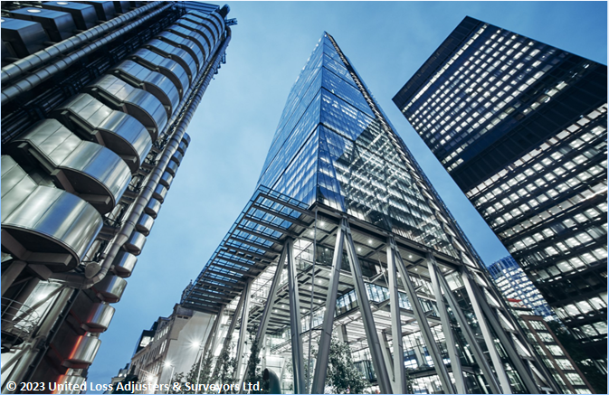

Document Control Page
Written by: | Reviewed By: | Approved by:
Estefani Haddad | Annie Abdel Massih | Petro Zaarour
Designation: | Designation: | Designation:
Claims Administrator | Claims Director | UKI Chartered Engineer & Average Adjuster
Signature (Approver)
This survey and its issued report were completed without prejudice to all rights of parties concerned.
Date of approval
27 March 2026

Version History | Date of issue | Reason for Revision
1 | 27 March 2026 | Issued - Final

The contents of this report are for the confidential information of the client
This survey and its issued report were completed without prejudice to all rights of parties concerned.

Report Summary
At the request of M/s. Lia Assurex SAL (the Applicant), the undersigned Surveyor to ULA, was requested to investigate an air cargo claim for Mr. Bechara Tony Raad (the Assured) and validate their claim on the subject policy when presented. The insured cargo in question consisted of “Artist Proof-Pure Pigment Print” (painting). This request was following a notification pertaining to the loss of the insured cargo during the insured air transit. Table 1 is a summary with details pertaining to this claim, and Appendix A contains its representative photograph.
Table - Claim summary and salient details
Applicant’s / Insurer’s | M/s. Lia Assurex S.A.L.
Assured’s | Mr. Bechara Tony Raad
Shipper’s Name | M/s. Laboratorio Cornici Telò Mauro, Italy
Receiver’s Name | Mr. Yousif Abou Zahr, Lebanon
Policy Details | No. HO-MAP-0103552 End. 1  Insured Value: Euro 12,000.00 = USD 14,040.00  All Risks as per Institute Air Cargo clauses; Warehouse to warehouse; Warranted professionally & suitably packed; Deductible 10% min USD 500.00 on claim amount
Booking Note | Tracking No. 1Z417V208658737740 issued by M/s. UPS
- Shipment of Gabriele Basilico artwork from Milan to Beirut was arranged on 10 Dec 2025 under UPS Tracking No. 1Z417V208658737740, initially declared at USD 700.
- Collected on 22 Dec 2025, transferred to Milan and Seriate facilities, requiring additional clearance; export documentation and corrected invoice (EUR 12,000) submitted on 15 Jan 2026.
- UPS classified it as a work of art, subject to Ministry of Cultural Heritage regulations; shipment scheduled for return on 20 Jan 2026 due to storage expiry.
- Repeated correspondence ensued; crate became untraceable on 11 Feb 2026, last scanned in Seriate.
- UPS investigation closed on 23 Feb 2026 and 3 Mar 2026 notice declared shipment lost in transit; formal claims process initiated.
- Pre-loading photographs requested were not provided, but a photo of the artwork was received (Appendix A).
In our opinion,
- The adjusted claim on the policy/policy indemnity of USD 12,636.00 is fair and reasonable.
- The loss occurred before its dispatch from Italy to Lebanon while the shipment was under the custody of the carrier, M/s. UPS as carrier should be liable for the subject loss for failure to properly care for and deliver the subject shipment;
- The Assured had not been in breach of any policy, warranty, or condition which could bar them from recovering on the subject policy;
- We were able to confirm that the consignment was never delivered to the Consignee, as substantiated by the notice issued by the Carrier. At the time of loss, Insurers were on risk, and the Assured had an insurable interest in the goods. As such, the subject claim should be recoverable as a fortuitous loss by theft under Clause 1 of the Institute Air Cargo CL 370.
- We confirm sighting the originals of all received documents (see enclosed), made available in support of a claim of this nature.
Contents
1. Introduction 5
2. Interest Insured 5
3. Adjuster’s note 5
4. Cause of Loss 6
5. Warranties/Conditions and Insurable Interest 7
6. Appointment of assessors 7
7. Adequacy of the insured value 7
8. Claim & Adjustment 7
9. Conclusion 7
Appendix A Photograph Representing The Artwork 9

Introduction
At the request of M/s. Lia Assurex SAL (the Applicant), the undersigned Surveyor to ULA, was requested to investigate an air cargo claim for Mr. Bechara Tony Raad (the Assured) and validate their claim on the subject policy when presented. The insured cargo in question consisted of “Artist Proof-Pure Pigment Print” (painting). This request was following a notification pertaining to the loss of the insured cargo during the insured air transit. Table 1 is a summary with details pertaining to this claim, and Appendix A contains its representative photograph.
It is important to note that the seller is a Dubai-based company called AAZ Art Advisory; it is not an Italian company, and the artwork is only being printed in Italy as advised by the Assured.
Table 1 - Claim summary and salient details
Applicant’s / Insurer’s Name | M/s. Lia Assurex S.A.L.
Assured’s / Consignee’s Name | Mr. Bechara Tony Raad
Policy Details | No. HO-MAP-0103552 End. 1  Insured Value: Euro 12,000.00 = USD 14,040.00  All Risks as per the Institute Air Cargo clauses CL 370  Warehouse to warehouse  Warranted professionally & suitably packed  Deductible 10% min USD 500.00 on claim amount
Freight Forwarder / Carrier | M/s. UCS Express Freight Logistics - Authorized Service Contractor for the carrier M/s. UPS
Booking Note | Tracking No. 1Z 417 V20 86 5873 7740 issued by M/s. UPS
Shipper’s Name | M/s. Laboratorio Cornici TELò MAURO, Italy
Receiver’s Name | Mr. Yousif Abou Zahr, Lebanon
Seller Name | M/s. AZZ Art Advisory (as per enclosed emails, the seller is a Dubai-based company called AAZ Art Advisory; it is not an Italian company, the artwork is only being printed in Italy. The transaction is going through a company in Dubai, not an Italian company.
Voyage from/ Voyage to | Milan, Italy / Beirut, Lebanon
Commodity | 1 Gabriele Basilico, Beirut 1991-rue Gourand, Artist Proof – Pure pigment print, 2022, 100 × 130 cm, Estate.
Cause of loss | Cargo lost during the insured transit
Date of loss discovery | 23 February 2026

Interest Insured
1 Gabriele Basilico, Beirut 1991-rue Gourand, Artist Proof – Pure pigment print, 2022, 100 × 130 cm, Estate, was arranged to be forwarded by air from Milan to Beirut, Under Policy No. HO-MAP-0103552, with an insured value of Euro 12,000.00, covered under All Risks as per Institute Air Cargo clauses.

Adjuster’s note
- On 10 December 2026, the Consignee contacted M/s. UPS to arrange the shipment of 1 Gabriele Basilico, Beirut 1991-rue Gourand, Artist Proof – Pure pigment print, 2022, 100 × 130 cm, Estate from Milan, Italy to Beirut, Lebanon, initially declaring a value of USD 700.00 for shipping purposes.
- The shipment was collected on 22 December 2025 in Milan, under UPS tracking number 1Z417V208658737740, and transferred to the UPS facility in Milan and subsequently Seriate, Italy, where additional clearance information was requested.
- On 8 January 2026, UPS Italy advised that the shipment had been classified as a work of art, which is subject to the protection of the Ministry of Cultural Heritage and requires specific documentation, stamped and certified by a Ministry office, to be exported.
- On 15 January 2026, the required export documentation and the corrected commercial invoice reflecting the real value of EUR 12,000.00 were submitted to UPS in compliance with the applicable regulations.
- On 20 January 2026, UPS advised that the shipment had been scheduled for return due to the expiration of the storage period. Subsequent correspondence between the consignee and UPS consisted of repeated requests for updates regarding the shipment’s status and location.
- On 11 February 2026, it was reported that the crate had become untraceable while in the custody of UPS (while stored inside their warehouse), and confirmation was requested regarding the last scan, last recorded location, and the outcome of the investigation.
- UPS advised that an investigation into the lost shipment had been opened on 02 February 2026.
- According to the available tracking records, the shipment was last scanned in Seriate, Italy, after which its whereabouts could no longer be confirmed.
- On 23 February 2026, the UPS investigation was closed, with the shipment remaining unlocated.
- On 02 March 2026, M/s. AZZ Art Advisory (The Seller) issued a notice of loss addressed to the carrier M/s. UPS, informing them about the loss of the shipment and holding them liable (Copy enclosed).
- Subsequently, a notice was issued by UCS Express Freight Logistics - Authorized Service Contractor for the carrier M/s. UPS - dated 03 March 2026, stating that the shipment transported from Italy to Lebanon under tracking number 1Z417V208658737740 had been declared lost in transit following extensive tracing efforts and an investigation conducted with their international network, including the origin station in Italy and transit hubs. UCS further advised that, in accordance with their policy and international carriage terms, the formal claims process would be initiated, while expressing their regret for the inconvenience caused (Copy enclosed).
- The Assured further advised that the shipment value declared to UPS for transport purposes was USD 700, which is reportedly common practice for artworks shipped to Lebanon due to the high duties and taxes, which could exceed approximately 30% of the value.
- Pre-loading photographs of the shipment were requested from the consignee for inspection and verification purposes; however, these were not available. A photograph of the artwork itself was received (See Appendix A).

Cause of Loss
In the opinion of the surveyor, the cargo was lost whilst in the custody of the carrier UPS, when insurers were still on risk and the Assured/Assignee had an insurable interest. Based on the investigations conducted, including review of tracking records, correspondence and documentation, it is confirmed that the subject claim is genuine and has been submitted in good faith by the Assured.

Warranties/Conditions and Insurable Interest
On review of the subject policies, we are of the view that no warranties or conditions were breached, which could bar the Assured or Assignee from recovering on their policy.

Appointment of assessors
To date, the Assured had not appointed a loss assessor or Surveyor to act on their behalf.

Adequacy of the insured value
The value of the subject consignment is equivalent to the sum insured, indicating that coverage is appropriate. Therefore, we were able to conclude that there is no evidence to suggest underinsurance.

Claim & Adjustment
On receipt of invoice No. 2025/VE1/64 issued by M/s. Galleria Michela Rizzo (GMR) dated 09 December 2025, the claimed policy indemnity is presented in Table 2 below, outlining their presented claim on the policy.
Table 2 - Quantum of loss presented on the policy
Description | Quantity | Total Amount
Gabriele Basilico, Beirut 1991-rue Gourand, Artist Proof – Pure pigment print, 2022, 100 × 130 cm, Estate | 1 | Euro 12,000.00 Equivalent to USD 14,040.00
Adjusted Claimed Amount --------------------------------------------------------------------------------- USD 14,040.00
Less, Deductible 10% min 500.00 USD on claim amount--------------------------------------------USD 12,636.00
Say, USD Twelve Thousand Six Hundred Thirty-Six Only.

Conclusion
In our opinion,
- The adjusted claim on the policy/policy indemnity of USD 12,636.00 is fair and reasonable.
- The loss occurred prior to its dispatch from Italy to Lebanon while the shipment was under the custody of the carrier, M/s. UPS. The carrier should be liable for the subject loss for failure to properly care for and deliver the subject shipment.
- The Assured had not been in breach of any policy, warranty, or condition which could bar them from recovering on the subject policy.
- We were able to confirm that the consignment was never delivered to the Consignee, as substantiated by the notice issued by the Carrier / Freight forwarder. At the time of loss, Insurers were on risk, and the Assured had an insurable interest in the goods. As such, the subject claim should be recoverable as a fortuitous loss by theft under Clause 1 of the Institute Air Cargo CL 370.
We confirm sighting the originals of all received documents (see enclosed), made available in support of a claim of this nature.
Claim Documents
Enclosed Documents:

- Insurance Policy No. HO-MAP-0103552 End. 1
- UPS airwaybill
- Invoices
- Notice of Claim
- Shipper’s Copy
- Claim Form
- Communications
- Notice from UPS
- Tracking
Outstanding/ Not Available Documents:
- Terms of Sale / Incoterm
- Preloading photographs

            - Photograph Representing The Artwork
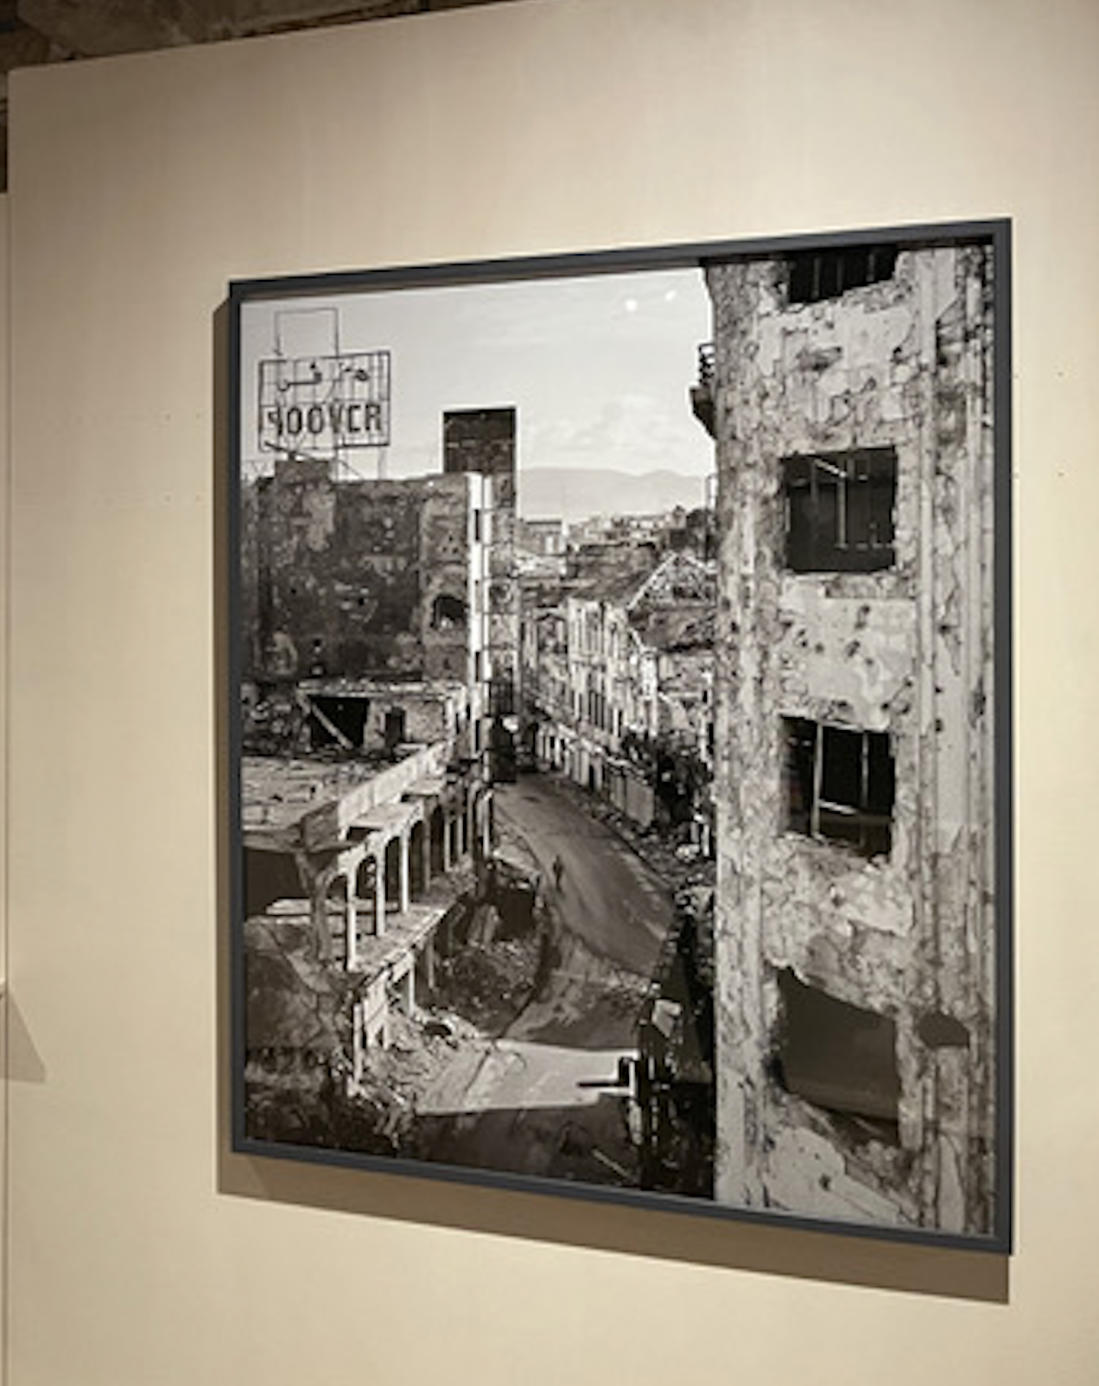

About ULA
United Loss Adjusters and Surveyors (ULA) is a leading international provider of Adjusters, Surveyors, Solicitors and Consultants, offering unrivalled technical and legal solutions with exclusive access to the London Market's leading specialists.
Established in 2002, ULA boasts strategic headquarters in both the Middle East and the United Kingdom. Today, it stands as the key strategic ally of Clyde & Co., operating across 60+ countries, and serves as the correspondent and associate for numerous global technical service providers present in over 140 countries. ULA clientele includes esteemed entities such as insurers, reinsurers, brokers, P&I clubs, ship owners, shipyards, H&M insurers, agencies, and various other stakeholders.
Lines of business:
- Insurance & Re-insurance
- Claims solutions and loss adjusting across all major lines: aviation, cargo, marine, property, fine arts and special risks claims
- Cargo & Containers
- Marine & Offshore
- Global Claim Recoveries & Legal Support
Our team:
Our team comprises seasoned professionals proficient in Marine, Insurance, Finance, Engineering, and Law, renowned for their integrity and credibility. Backed by a dynamic, strategically located workforce, we swiftly address your queries with promptness and precision whenever and wherever our services are required. ULA maintains unwavering independence, ensuring unbiased perspectives uninfluenced by stakeholders, thereby earning your trust unequivocally.
ULA’s team members are recognised:
- Chartered Engineers
- Consultants
- Inspectors & Auditors
- Insurance & Re-Insurance Underwriters
- Loss & Average Adjusters
- Master Mariners & Chief Engineers
- Naval Architects, Marine & Offshore Engineers
- Solicitors
- Sworn Surveyors
ULA’s team members are also recognised members of the following international institutions:
- The Association of Average Adjusters (AAA)
- The Bar Council of England and Wales
- The Chartered Insurance Institute (CII)
- The Chartered Institute of Loss Adjusters (CILA)
- The European Federation of Loss Adjusting Experts (FUEDI)
- The Institute of Fire Engineers (IFE)
- The Institute of Marine Engineering, Science and Technology (IMarEST)
- The UK Engineering Council
- The Royal Institute of Naval Architects (RINA)
- The International Institute of Marine Surveying (IIMS)
- The Royal Institute of Chartered Surveyors (RICS)

Contact person
Hovig Kalandjian
Senior surveyor
United Kingdom: 71-75 Shelton Street, Covent Garden | London, England - WC2H 9JQ

Registered name United Loss Adjusters and Surveyors Ltd.

24/7 Contacts & Claims support – T: +44 (0) 20 3287 3326 | M/WhatsApp: +44 (0) 7 375 110 573
Office E: claims@unitedlossadjusters.com
W: https://www.unitedlossadjusters.com/



